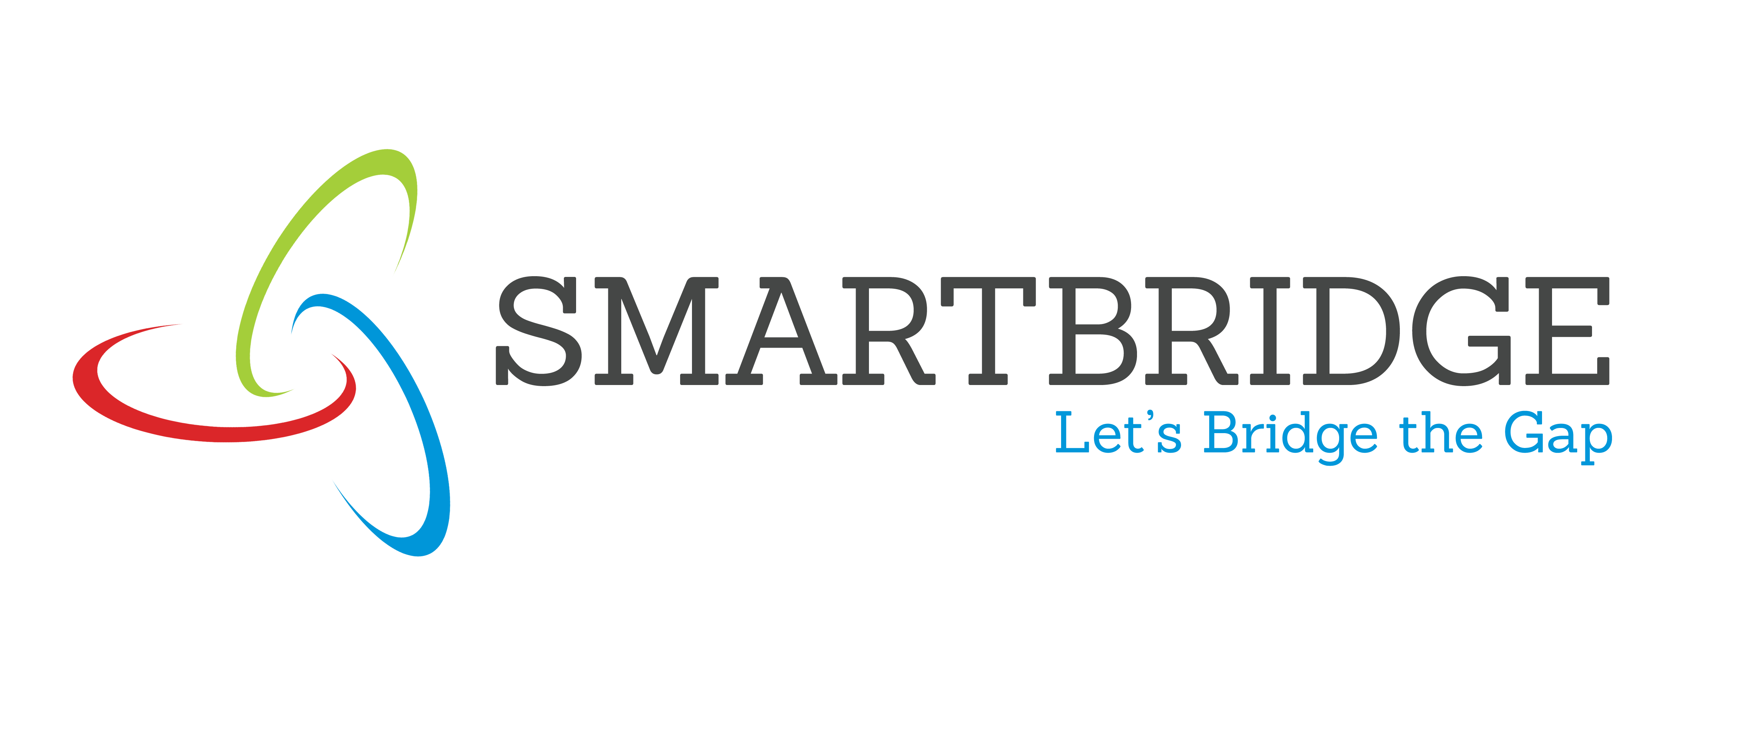

**INTERNSHIP REPORT APPROVAL FORM**

July 1, 2019

With immense pleasure, this is to approve that the students of Sona College of Technology i.,e

**RAVIKUMAR J**

**YATHUSUN R**

**MOHAMED ASHIF ABDULLA J**

successfully completed their Project and Project Report on **“FOREST FIRE Prediction”** under our guidance.

We are highly impressed with the work that they have done and commend them on their quick grasping skills. They have shown good intent to learn and have put the knowledge gained into application in the from of this project. We appreciate the hard work and commitment shown by them.

We, hereby approve that this document is completely checked and accepted by SmartBridge Technical Team. Its been an absolute pleasure to educate and mentor these students. We hope that this document will also serve as a Letter of Recommendation, to whomsover applied.

We wish them success in all future endeavors and a great career ahead.

**GD Abhishek**

AI Developer